OS
1. Introduction 1
2. Kernel 2
3. Short History of Operating Systems 2
4. OS structure 2
a. Layered OS with modules 3
5. Trap (Invoking System Calls) 4
6. User Mode & Kernel Mode 4

Introduction
- An operating system (OS) sits between the hardware and programs.
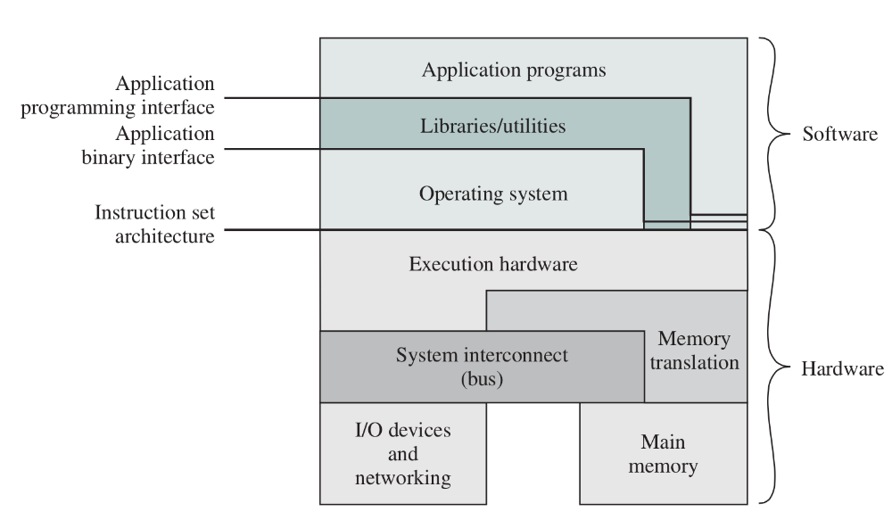

- 1. Resource Manager
  - The OS is responsible for resource management and allocation. The OS must decide how to allocate & to keep track of system resources.
  - Resources like CPU time or memory space are limited.
- 2. Environment Provider
  - The OS is responsible for abstracting away the details of hardware
- 3. Multitasking
  - Multiple programs means some resources are shared, OS creates and enforces the rule so all can get along.
- 4. Efficiency
  - Use the computer hardware efficiently

Kernel
- System programming: the next layer above the OS itself.
- Examples of system programming:
  - File Manipulation
  - Status Information
  - Programming-Language support
  - Communication

Short History of Operating Systems
- First Generation
  - Vacuum tube generation
- Second Generation
  - The era of the mainframe
- Third Generation
  - Integrated circuits (IC) and multiprogramming
  - Major innovation: timesharing
- Fourth Generation
  - The age of PCs
  - Apple use GUI invented by Xerox

OS structure
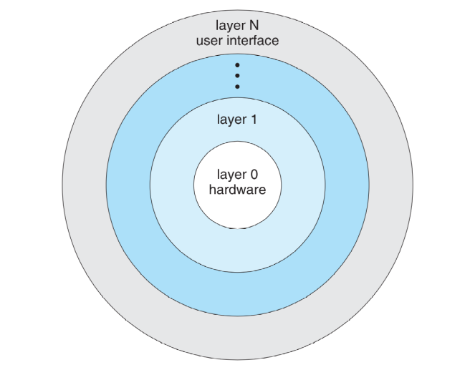

- Layered Structure
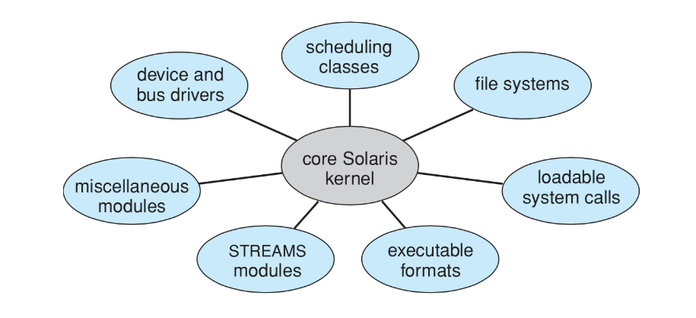
- Another structural element within a layer: modules
Sun Solaris Structure:

Layered OS with modules
- Provides the environment for the execution of programs
- Supports them in their execution by providing various services
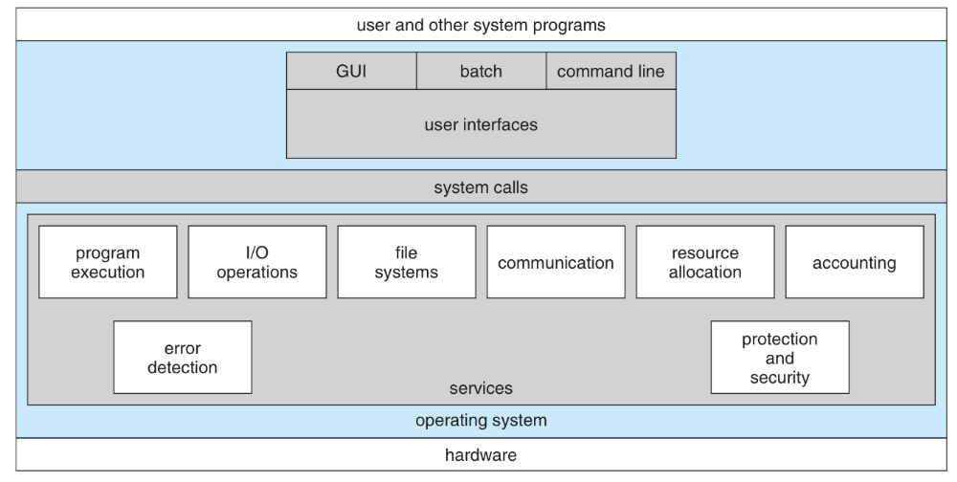

Starting from the top:
- User Interface
- System Calls
- Program Execution
- I/O Operations
- File Systems
- Communication
- Resource Allocation
- Accounting
- Error Detection
- Protection and Security

Trap (Invoking System Calls)
A trap is a software-generated interrupt.
System Call Summary:
The steps, arranged chronologically, when invoking a system call are:
  - The user program pushes arguments onto the stack.
  - The user program invokes the system call.
  - The system call puts its identifier in the designated location.
  - The system call issues the trap instruction.
  - The OS responds to the interrupt and examines the identifier in the designated location.
  - The OS runs the system call handler that matches the identifier.
  - When the handler is finished, control exits the kernel and goes back to the system call (in user mode).
  - The system call returns control to the user program.

User Mode & Kernel Mode
- User mode / Kernel mode
- Modern processors track what mode they are in with the mode bit
  - At boot up, the computer starts up in kernel mode as the OS is started and loaded
  - User programs are always started in user mode.
  - When a trap or interrupt occurs, and the OS takes over, the mode bit is set to kernel mode
  - When it is finished the system goes back to user mode before the user program resumes
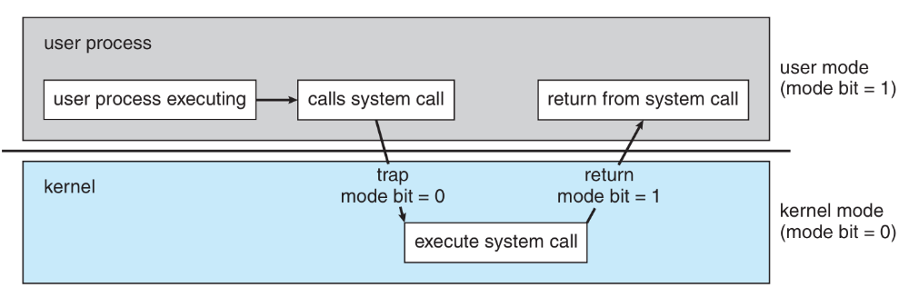
- Text Editor Printing example:

- Example: Reading from Disk: (C code to perform a read on a UNIX system. )
  - Read takes 3 parameters: int bytesRead = read( filename, buffer, numBytes );
    - The file name
    - Where to read the data to;
    - How many bytes to read
  - Note that read returns the number of bytes successfully read.
    - To prepare for a call to read, the parameters are pushed on the stack
    - Read is called; the normal instruction to enter another function
    - The read function will put its identifier in a predefined location
    - Then it executes the trap instruction, activating the OS.
    - The OS takes over and control switches to kernel mode
    - Control transfers to a predefined memory location within the kernel
    - The trap handler examines the request: it checks the identifier
    - Now it knows what system call request handler should execute: read.
    - That routine executes
    - When it is finished, control will be returned to the read function, exit the kernel and return to user mode
    - Read finishes and returns, and control goes back to the user program

